Introducing the Web Audio API
This Chapter introduces the Web Audio API. It explains the motivations behind it, and compares it to other APIs, packages and environments for audio programming. It gives an overview of key concepts, such as the audio graph and how connections are. The AudioContext is introduced, as well as a few essential nodes and methods that are explored in more detail in later chapters. A 'hello world' application is presented as a code example, showing perhaps the simplest use of the Web Audio API to produce and manipulate sound. We then extend this application to show alternative approaches to its implementation, coding practices, and how sound is manipulated in an audio graph.

The Web Audio API
The Web Audio API is a high level Application Programming Interface for handling audio operations in web applications. It makes audio processing and analysis a fundamental part of the web platform. It has a lot of built-in tools, but also allows one to create their own audio processing routines within the same framework. Essentially, it allows one to use a web browser to perform almost any audio processing that one could create for stand-alone applications. In particular, it includes capabilities found in modern game engines and desktop audio production applications, including mixing, processing, filtering, analysis and synthesis tasks.
The Web Audio API is a signal flow development environment. It has a lot in common with visual data flow programming, like LabView, Matlab’s Simulink, Unreal’s BluePrint, PureData, or Max MSP. They all provide a graphical representation of signal processing. But unlike the others, The Web Audio API is text-based Javascript, not graphical. There are third party tools to work with a graphical representation for Web Audio development, but they are still in early stages.
With the Web Audio API, one can define nodes, which include sound sources, filters, effects, and destinations. One can also create his or her own nodes. These nodes are connected together, thus defining the routing, processing and rendering of audio.

The Audio Context
Audio operations are handled within an audio context. The audio operations are performed with audio nodes (consisting of sources, processing and destinations), and the nodes are connected together to form an audio routing graph. The graph defines how an audio stream flows from sources (such as audio files, streaming content or audio signals created within the audio context) to the destination (often the speakers).
The audio context is defined with a constructor, AudioContext(), as we will see in the HelloWorld example below.
All routing occurs within an AudioContext containing a single AudioDestinationNode, In the simplest case, a single source can be routed directly to the output, as in Figure 1.1. The audio nodes as blocks. The arrows represent connections between nodes. Nodes
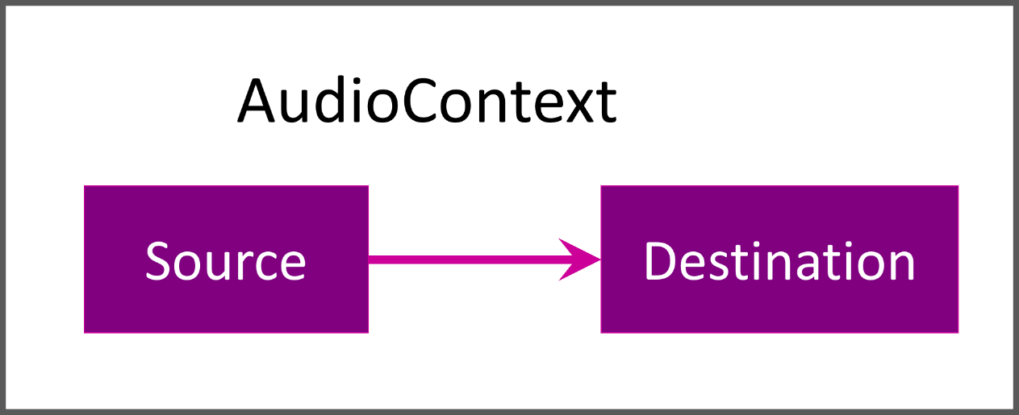
Figure 1.1. The simplest audio context.
Modular routing allows arbitrary connections between different audio nodes. Each node can have inputs and/or outputs. A source node has no inputs and a single output. Sources are often based on sound files, but the sources can also be real-time input from a live instrument or microphone, redirection of the audio output from an audio element, or entirely synthesized sound.
A destination node has one input and no outputs. Though the final destination-node is often the loudspeakers or headphones, you can also process without sound playback (for example, if you want to do pure visualization) or do offline processing, which results in the audio stream being written to a destination buffer for later use.
Other nodes such as filters can be placed between the source and destination nodes. Such nodes can often have multiple incoming and outgoing connections. By default, if there are multiple incoming connections into a node, the Web Audio API simply sums all the incoming audio signals. The developer also doesn’t usually have to worry about low-level stream format details when two objects are connected together. For example, if a mono audio stream is connected to a stereo input it should just mix to left and right channels appropriately.
Modular routing also permits the output of AudioNodes to be routed to an audio parameter that controls the behavior of a different AudioNode. In this scenario, the output of a node can act as a modulation signal rather than an input signal.
A single audio context can support multiple sound inputs and complex audio graphs, so generally speaking, we will only need one for each audio application we create.
The default nodes of the Web Audio API are fairly minimal, only 19 in all.
- Audio​Buffer​Source​Node
- Media​Element​Audio​Source​Node
- Media​Stream​Audio​Source​Node
- Constant​Source​Node
- Oscillator​Node
- Biquad​Filter​Node
- Channel​Merger​Node
- Channel​Splitter​Node
- Convolver​Node
- Delay​Node
- Dynamics​Compressor​Node
- Gain​Node
- PannerNode
- Stereo​Panner​Node
- Wave​Shaper​Node
- IIRFilter​Node
- Analyser​Node
- Media​Stream​Audio​Destination​Node
- Audio​Destination​Node

The first five are all source nodes, defining some audio content and where it comes from. The last three are all destinations, giving some output. Everything else is an intermediate node, which processes the audio, and has inputs and outputs. We will be talking about all of these nodes, including providing examples, in later sections. We will also introduce the AudioWorkletNode, which provides the means to design your own audio node with its own functionality.
To give you a sense of how these nodes might be used, another graph is shown in Figure 1.2. The idea of this graph is to shape some noise and add some effects, perhaps to create a boomy explosion. An audioWorkletNode is used to generate a continual noise source. A time vary gain is applied by automating parameters on a gain node. Then a filterbank of BiquadFilterNodes is applied to shape the frequency content, which is then summed back together into another gainNode. This is then passed through a waveshaperNode to add distortion, based on a waveshaping curve, and a convolverNode to add reverberation, based on an impulse response. Finally, this is sent to the destination and heard by the user. Several of the nodes in this example take additional information besides audio streams and simple parameter settings, such as an array of automation curve values for the first gain node, a waveshaping curve for the waveshaper, and an audio buffer for the convolver.
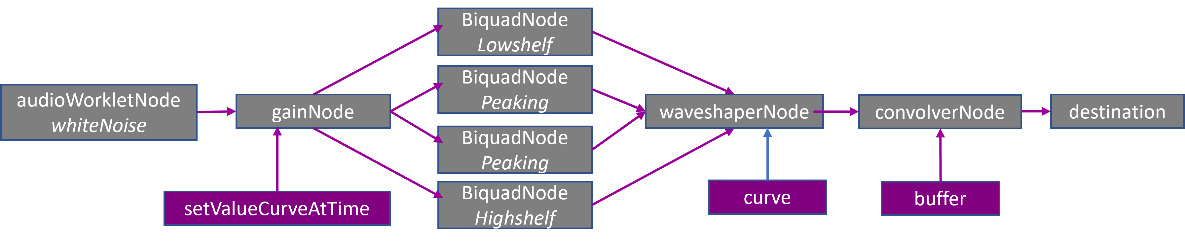
Figure 1.2. A complex audio routing graph. It applies an envelope, filterbank, distortion and reverb to noise.
If much of that explanation does not make sense, don’t worry. One of the main purposes of this book is to introduce and explain all of these nodes, in sufficient detail that you should be able to use them to achieve whatever audio processing goal you have in mind. But now, let’s give our first code example.

Example - Hello World
In Code example 1.1 we have possibly the simplest program using the Web Audio API. It just plays a simple sinusoid, the Web Audio equivalent of a ‘Hello World!’ application.
<button onclick='context.resume()'>Start</button>
<script>
var context= new AudioContext()
var Tone= context.createOscillator()
Tone.start()
Tone.connect(context.destination)
</script>

Code example 1.1. Hello World Application, generating sound
Most browsers will know this is an html file and display it correctly. Inside <script> and </script> is the Javascript code that uses the Web Audio API. A new AudioContext is created. It has a single OscillatorNode, with default settings. We will introduce the oscillator node later, but for now its sufficient to note that it is a source node that generates a periodic waveform, and with its default values it is a 440 Hz sine wave.
The oscillator is started, and connected to the destination. Any audio node’s output can be connected to any other audio node’s input by using the connect() function. context.destination is an AudioDestinationNode , sending the audio stream to the default audio output of the user’s system.
However, the script by itself will not do anything. The audio context is suspended by default, and needs to be started by some user interaction. We did this by creating a button on the web page, and having that perform the line context.resume() when clicked.
This Hello World application does not showcase any intermediate processing. That is, the source is connected directly to the destination. So let’s extend it a little bit. In Code example 1.2, we have added a gain node, which simply multiplies the input by some value, in order to produce the output. We set that value to 0.25. Now, the source tone is connected to the gain node and the gain node is connected to the destination. So the oscillator’s signal level is reduced by one fourth.
<button onclick='context.resume()'>Start</button>
<script>
var context= new AudioContext()
var Tone= context.createOscillator()
var Volume= context.createGain()
Volume.gain.value=0.25
Tone.start()
Tone.connect(Volume)
Volume.connect(context.destination)
</script>

Code example 1.2. Hello World, version 2.
Let’s take a step back now and look at a few lines of code in detail. Changing the gain of an audio signal is a fundamental operation in audio applications. createGain is a method of an audioContext that creates a GainNode. The GainNode is an AudioNode with one input stream and one output stream. It has a single parameter, gain, which represents the amount of gain to apply. Its default value is 1, meaning that the input is left unchanged.
Alternatively, we could have created a new gain node directly using a gainNode constructor. This takes as input the context and optionally, parameter values. Besides allowing us to set the parameters when created, it can be slightly more efficient than the createGain method. Also, serial connections can be combined as A.connect(B).connect(C) … So we can rewrite this as in Code example 1.3.
<button onclick='context.resume()'>Start</button>
<script>
var context= new AudioContext()
var Tone= new OscillatorNode(context)
var Volume= new GainNode(context,{gain:0.25})
Tone.start()
Tone.connect(Volume).connect(context.destination)
</script>
Code example 1.3. Hello World, version 3.
The resulting audio graph, shown in Figure 1.3, is the same for Code example 1.2 and Code example 1.3.
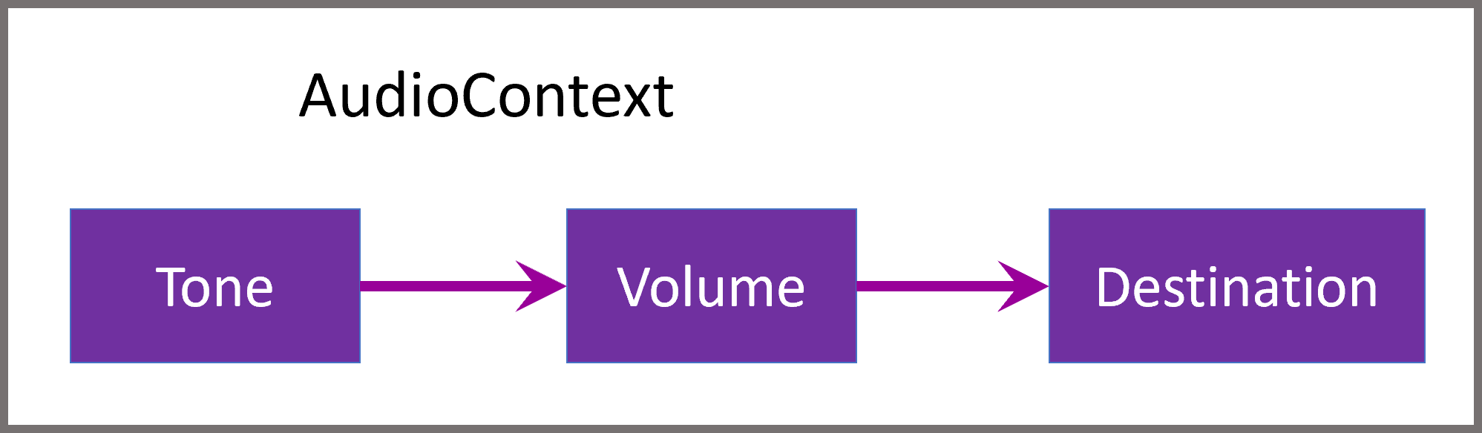
Figure 1.3. A simple audio graph to generate a tone with reduced volume.

Example - Adding user interaction
The web page that this will render is static. That is, other than clicking the Start button, there is no user interaction with it. It simply plays out the tone. So now we will add some interaction, allowing the user to change some parameters of the audio nodes.
First, note that it is generally good practice to separate the front-end, user interface-related code, from the back-end, processing and access-related code. For a lot of web applications, this also makes sense since the front-end is mostly html and css files, and the back-end is almost entirely javascript. So lets follow that practice here.
We want the gain parameter of the gain node to be controlled by the user. So we will add a slider to the interface. In html, these are known as range controls. We made this range control so that it can assume values from 0 to 1 in increments of 0.01. When the user moves the slider, it will update the gain parameter value with the value of the sliders.
There are a few points to note here. For the gain control, we called the actual user interface element VolumeSlider, and called the audio node Volume. Also, we never defined a variable VolumeSlider. We can access it because the web browser defines the html element IDs as global variables. This was nice for giving us simple code for the example, but its often better to be explicit and use document.getElementById('someElement') rather than just someElement.
Now lets add a few more features to make this a little more functional.
The slider is nice, but we might want to see the actual gain value that is used. So we can display these amounts in the html with <span id='SomeLabel'> and </span> in the html file and SomeLabel.innerHTML = SomeValue in the JavaScript file.
We also want to replace the Start button with a Start/Stop button to turn the sound on and off. But the Web Audio API does not allow oscillators to be started more than once (I don’t know why, and certainly calling start() and stop() is the intuitive way to turn a sound source on and off). So there are a few ways around this. One can pause the whole audio context with context.suspend(), but here we would like to stop just one node. One could create a new oscillator each time, which could be done by creating the oscillator, setting its values and connecting it all inside the StartStop function. But this involves a little extra code and thought. And it’s inelegant since all other nodes are created consistently elsewhere. Another solution is to connect or disconnect the oscillator rather than start or stop it.
This is shown in Code example 1.4. An oscillator is created but initially unconnected. If the StartStop button is clicked while the oscillator is unconnected, the oscillator is connected to a gain node. If the button is clicked while the oscillator is connected, it disconnects the oscillator. A change in the VolumeSlider value will update both the value of the Volume node's gain parameter and the text in the VolumeLabel html element with the value of the slider.
<button onclick='StartStop()'>Start/Stop</button>
<p>Gain</p>
<input type='range' min=0 max=1 value=0.1 step='any' id='VolumeSlider'>
<div id='VolumeLabel'></div>
<script src='UserInteraction.js'></script>

var context = new AudioContext()
var Tone = context.createOscillator()
var Volume = new GainNode(context,{gain:0.1})
Tone.start()
var Connected = false
Volume.connect(context.destination)
function StartStop() {
if (Connected == false) {
context.resume()
Tone.connect(Volume)
Connected = true
} else {
Connected = false
Tone.disconnect(Volume)
}
}
VolumeSlider.oninput = function() {
VolumeLabel.innerHTML = this.value
Volume.gain.value = this.value
}

Code example 1.4. UserInteraction.html and UserInteraction.js.
We now have our first Web Audio API application with user controls. It allows one to experiment with oscillators, listen to different volume settings, and disconnect the oscillator at will. For a lot of this, like the OscillatorNode and disconnect(), we only introduced just enough to show off some functionality. They will be more formally introduced, with more detail, in later sections.

